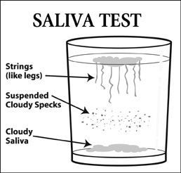

Try this simple test to see if you have candida. First thing in the morning, before you put ANYTHING in your mouth, grab a nice clear glass.
Fill with water and get some saliva worked up, then spit it into the glass of water. Check the water every 15 minutes or so for about an hour.
If you have a candida yeast infection, you will see strings (like legs) traveling down into the water from the saliva floating on the top, or
"cloudy" saliva will sink to the bottom of the glass, or cloudy specks will seem to be suspended in the water.
If there are no strings and the saliva is still floating after at least one hour, you are probably candida yeast free.

The following is a list of the more commonly known names:
- Candida
- Candida albicans
- Candida Related Complex
- Systemic candidiasis
- Candidiasis Hypersensitivity Syndrome
- Oral Thrush, Vaginal Thrush
- Moniliasis
- Polysystemic candidiasis

