Lightweight Backpack Stove

You can make this simple back packing stove with little cost ($0.25 US).

What You'll Need

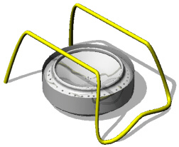
Parts List
- 2 Aluminum Soda Cans - Free
- 1/4 cup of Perlight (found in the gardening department) - $1.75 bag US
- Wire Coat Hanger - Free
- De-Natured alcohol (found in the paint dept. or boating supply) $3-4 Qt.

Tools
- Scissors
- Drill
- 1/16" (2 mm) Drill Bit
- Wire Cutters

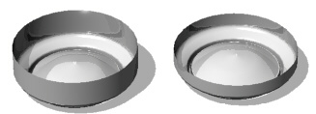
Step 1
For the base, neatly cut one can about 1 1/2" (3.5cm) from the bottom. For the top, cut the other can about 1" (3.5cm) from the bottom.

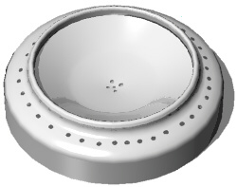
Step 2
Drill a number of holes (18-30) around the edge of the top and in the center as shown; use a 1/16" drill bit.

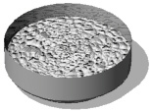
Step 3
Fill the base with Perlight, just more than half full.

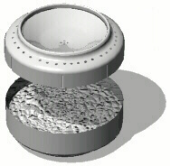
Step 4
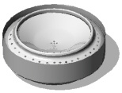
Make 6-8 vertical cuts around the top. Make the cuts up to but not over the rounded edge. Slowly press the top into the bottom. (A small board can help make it even.)

Step 5
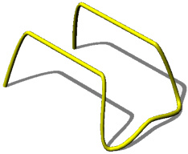
Fill the stove about half full of alcohol. Light the burner by slowly moving a match or lighter over the edge of the burner.Note:If it does not stay lit, tip the burner up to leak some fuel into the rim and re-light. Hold it until it stays lit or gets too hot.

Step 6
Cut and straighten a coat hanger. Use a fine sandpaper to remove any paint or coatings. Bend the coat hanger wire (or any large gauge wire) into a shape that will hold a pot a few inches above the burner (see the example). Note:with a little imaginations you can create a number of stove bases

