Surface Replacement of the Hip Joint.
(http://www.hipresurfacingindia.com/hip-resurfacing.php)

What is Hip Resurfacing- Hip resurfacing epitomizes medical achievements in arthroplasty. It is a conservative surgical technique of arthroplasty of the hip. In this the diseased surface of the head of femur is replaced with a cobalt chromium cap retaining all the healthy bone. The lining of the acetabulam is also replaced with the cobalt chromium cup. This mimics the natural hip closely and has near normal biomechanics, load transfer and range of movement at the hip joint. This surgery is performed under General Anaesthesia.( http://www.hipresurfacingindia.com)
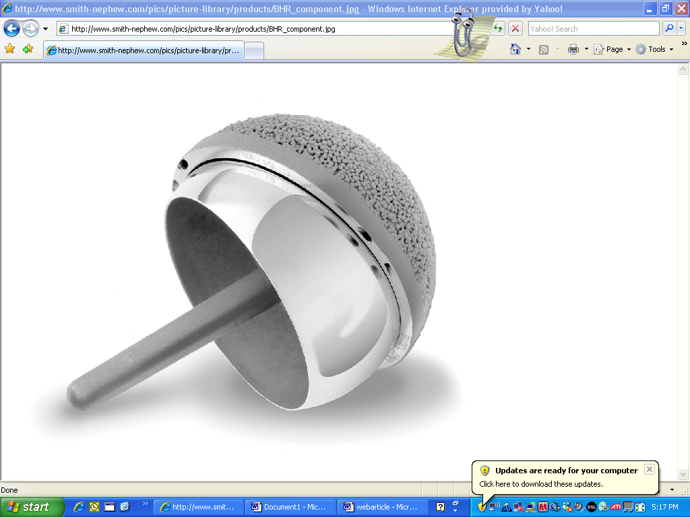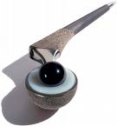

Hip Resurfacing prosthesis Total Hip Replacement Prosthesis

History of hip resurfacing- (http://www.hipresurfacingindia.com)
Hip Resurfacing Surgery was first performed by Dr.Derek Mc Minn and Dr.Ronan Treacy the inventors of the metal on metal prosthesis at the Royal Orthopeadic Hospital Birmingham in 1996. Hence the procedure went on to be known as the Birmingham Hip Resurfacing or the BHR.
- Birmingham Hip resurfacing was performed in India for the FIRST TIME in 2000 by Dr. Vijay C. Bose at Apollo Specialty hospital Chennai. He underwent training in Birmingham under Dr Treacy and Dr.Mc.Minn. Since then he has performed over 1000 Hip Resurfacing Surgeries at ARCH (Asian Regional Center for Hip Resurfacing). ARCH also boasts of Highest Number of Resurfacing Surgeries done for Avascular Necrosis of head of femur.
- In June 2002 the National Institute of Clinical Excellence (NICE) which is a medical advisory body in the U.K. recommended Metal on Metal Hip Resurfacing for all hip arthritics less than 65 years of age.
- The first Asia-Pacific single theme live Workshop on Metal on Metal hip resurfacing was conducted at Apollo Specialty Hospital in Chennai in March 2003 by Dr. Vijay C. Bose.
- In May 2006 The Birmingham hip resurfacing prosthesis which was now manufactured by Smith and Nephew received the Food and Frug Administration (FDA )approval in the United States of America.

Who needs Hip Resurfacing? (http://www.hipresurfacingindia.com)
Patients suffering from severe primary or secondary arthritis of the hip are advised to undergo hip resurfacing. This is indicated when medicines and other non surgical procedures have failed to control pain. This procedure resurfaces rather than replaces the head of femur. After hip resurfacing, patients are pain free and get back the original range of movement at the hip joint.

The Disease:
Primary osteoarthritis of the hip occurs in the older age group. Secondary Arthritis of the hip occurs in the younger age group and is more common in Asia. Secondary arthritis of the hip can be due to ankylosing spondylitis, rheumatoid arthritis, Avascular necrosis of the head of femur, Hip dysplasias or arthritis secondary to trauma.

Age:
Hip resurfacing can be done on arthritics less than sixty years of age. However patients over sixty with good bone density will also be suitable for hip resurfacing. Patients less than sixty years of age but having osteoporosis, especially female patients are not candidates for the procedure. The youngest patient to have undergone HRS surgery at Apollo Specialty hospital was 12 years old and the oldest was (65)

Activity Level:
Arthritics who would like to got back to a high range of physical activity benefit most from resurfacing.

Advantages of Hip Resurfacing . http://www.hipresurfacingindia.com/
- Relief from chronic pain associated with arthritis of the hip.
- Risk of dislocation is less in resurfacing as compared to replacement as it simulates the normal anatomy of the hip.
- Due to Metal on Metal interface, wearing of the artificial joint is less and usually doesn’t require revision surgery. Hence particularly useful for younger patients.
- Hip resurfacing is a Bone Conserving procedure. Only the diseased surface of the femur is removed hence recovery is faster. Revision arthroplasty if required is easier to perform because of spared bone.
- There is no restriction on personal, professional or recreational activities after this procedure. Unlike the total hip replacement after which patients cannot squat or sit cross-legged on the floor. The young and active benefit tremendously from this surgery.
- Deformities of the hip, shortening of limb and/ or limping due to long standing arthritis are corrected after hip resurfacing surgery.

The Center for Resurfacing - http://www.hipresurfacingindia.com/
The ARCH or the Asian Regional Center for Resurfacing is the First Specialized center for Resurfacing in Asia. Computer Navigated Surgeries are performed in state of the art theaters with laminar air flow. Internal ventilation surgical hoods provide very sterile environment for the implant surgery thus minimizing the chances of infection.
The newly inaugurated Platinum Ward in the hospital has state of art facilities that cater to all the needs of patients in the period of recovery after Hip Surgery.

The center has a team of specialized surgical consultants, anaesthetist, physiotherapists and well trained staff including an international patient’s coordinator.
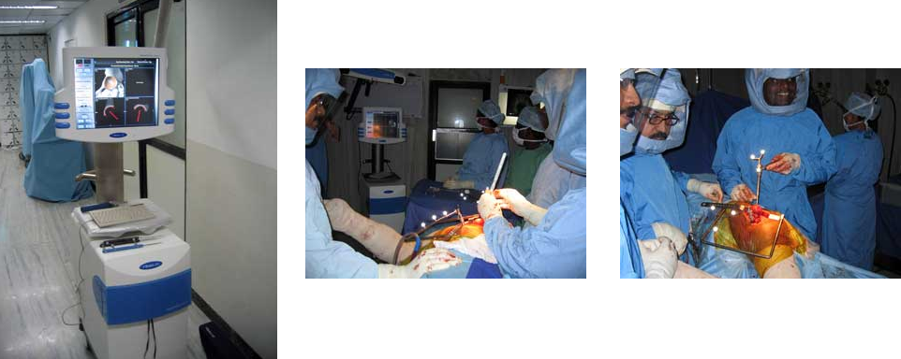

Computer aided navigation system Surgical hoods.

What to expect from Resurfacing? http://www.hipresurfacingindia.com
Patients have to be admitted one day before surgery or two days before if they are travelling from outside the country. The procedure itself takes two to four hours depending on the extent of the pathology. The hospital stay is usually for five days after the surgery. Patients from overseas recuperate for a week in a resort by the beach. Following surgery, they can walk on crutches by the second day, climb stairs by the fifth day and are back to work by the fifth week.


Trophies for Hip Resurfacing
Linda Pugilese Won the weapons division of Karate National Championship 2007 in U.S.A., one year after both her hips were resurfaced by Dr. Vijay Bose in Chennai.

Dr. William Cory Foulk took part in the 2006 Ironman Triathlon world Championship Ten months after having a Birmingham hip Resurfacing procedure with Dr. Vijay C Bose

For More Details for Hip Resurfacing, Total Hip Problems
Dr. Vijay C. Bose – Specialist in Hip Resurfacing

Consultant Orthopedic Surgeon
Asian Regional Center for Hip Resurfacing
Apollo Specialty Hospital, 320, Mount Road, Chennai - 600035. INDIA.
E-Mail: bose5vijay@hotmail.com
Telephone: 0091-44-(0) 98400 - 32251
Visit Us: http://www.hipresurfacingindia.com

