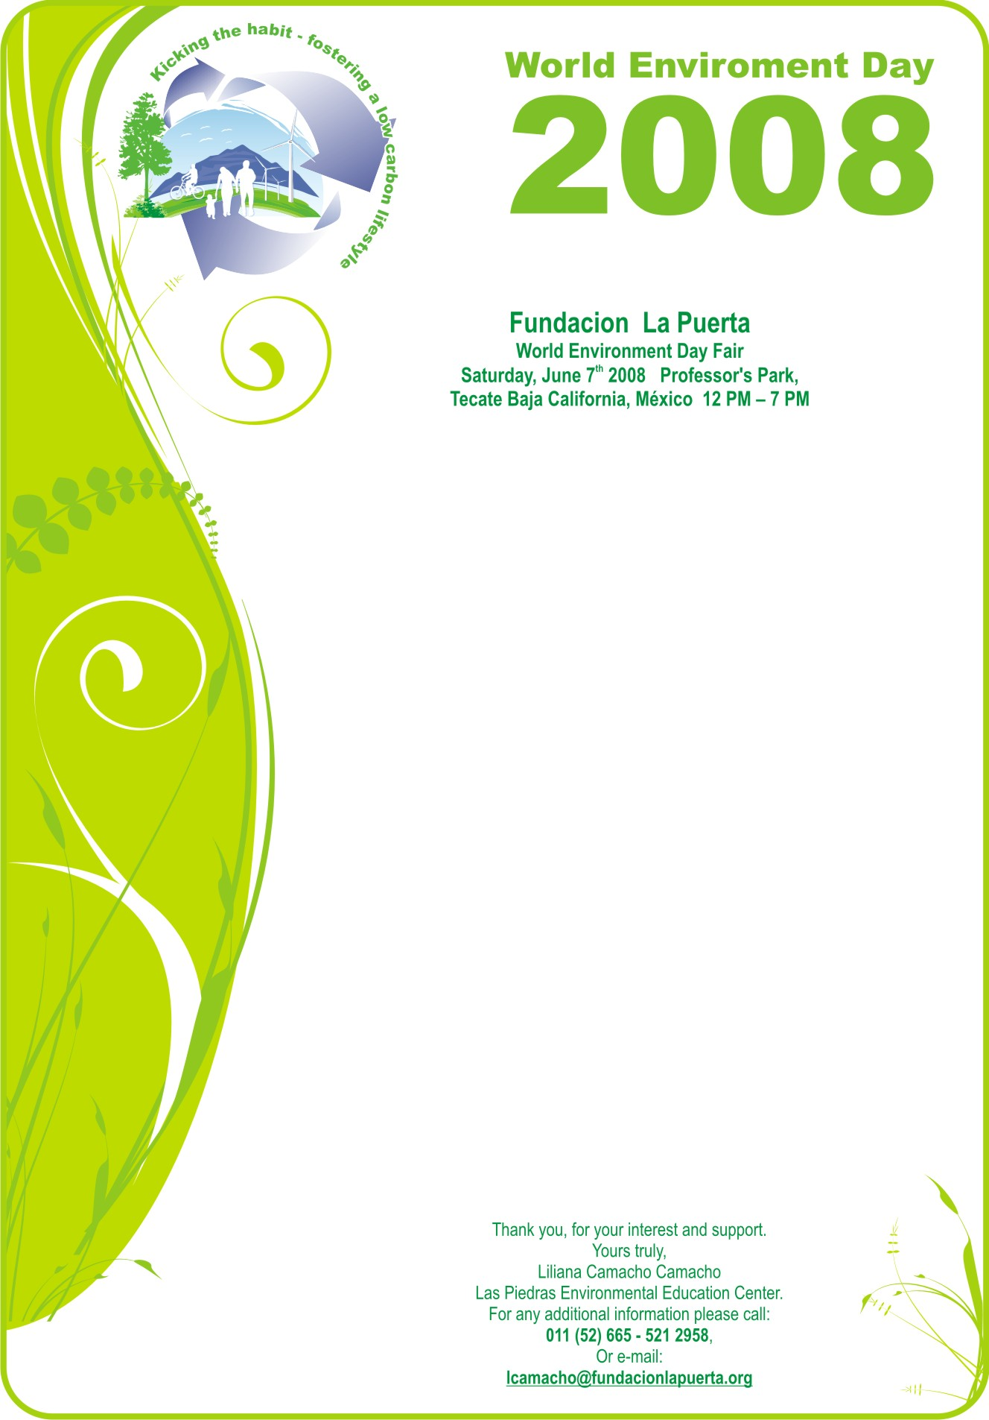

To Whom It May Concern:

Las Piedras Environmental Education Center is pleased to invite you to participate in its´ World Environment Day Fair, June 7th, from 12 p.m. to 7 p.m. at the Professor’s Park in Tecate, México.

We hope your organization can participate with an interactive exhibit that promotes environmental awareness and encourages a commitment to environmental protection. Our audience is Spanish speaking so we ask that all the activities and information be in Spanish.

We suggest the following topics for your exhibit, however if you already have a presentation that addresses another environmental topic that is not on this list, we ask you describe it in the registration form.

Some suggested topics are:
- Water quality and watershed.
- Solid waste management (organic and or inorganic).
- Biodiversity (importance, protection and conservation).
- Cultural diversity in context of the environment.
We hope that the exhibit will be informative, fun and will promote the love and respect for nature that comes from the understanding of the natural world and the comprehension of the human-nature relationship for the purpose of creating a more sustainable community.

Las Piedras will offer a table with its tablecloth and two chairs. We will also offer food and hats to all our participants. The participants are expected to bring all of the materials they will use during the event, such as extension cords, pens, paper, posters etc.

Your participation is very important to us. If you can join us, please fill out the registration form and e-mail it to us by May 19th 2008.

