Hip Resurfacing In India – Dr Vijay C Bose – Low Cost Hip Resurfacing – Knee surgery – Total Hip Replacement
http://www.hipresurfacingindia.com
Hip Resurfacing:
You are forty years old, great job, good friends and life is a smooth journey. One awful morning you wake up with a throbbing pain in the hip joint. You pop in a pain killer bought at the pharmacy and feel better. A few months later more frequent pain and sever enough to reduce movement at the hip joint. A visit to the orthopedic surgeon and series of medical test follows. Day to day activities become very difficult. You hear the inevitable news that you have osteoarthritis of the hip joint. The only treatment that will relieve your pain is replacement of the hip joint…
This is the relentless jargon of patients suffering from osteoarthritis of the hip. The conventional hip replacement involves cutting the head of femur (thigh bone) and replacing it with a metal ball. The diseased acetabulum is replaced with a high density polyethylene cup. The life of conventional Total Hip Replacement is about 10 to fifteen years. A superior alternative to this is the Birmingham Hip Resurfacing. The first procedure in India was performed at Apollo Specialty Hospital Chennai. In this procedure only the diseased part of the head of femur is removed and a metal cap made of cobalt and chromium is fitted on it. The acetabular side is also fitted with a metal cup. Due to the metal on metal interface the joint does not wear out easily. Moreover the resurfacing prosthesis has near normal anatomy to the hip joint. Hence patients can get back to all kinds of physical activities without the fear of dislocation. http://www.hipresurfacingindia.com/hip-resurfacing.php

Hip Resurfacing Procedure:
The Hip Resurfacing procedure is being performed since September 2000 and over thousand (1000) Hip Resurfacing Surgeries have been performed so far by Dr. Vijay. C. Bose.
Computer Navigated Surgeries are performed in state of the art theaters with laminar air flow. Internal ventilation surgical hoods provide very sterile environment for the implant surgery thus minimizing the chances of infection.

Platinum Ward Facility:
The newly inaugurated platinum ward in the hospital has state of art facilities that cater to all the needs of patients in the period of recovery after hip surgery.
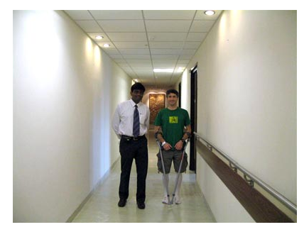
Dr Vijay C Bose with Patient in Platinum Ward at Apollo Specialty Hospital. http://www.hipresurfacingindia.com/New_Hip_Surgery_Facility.php

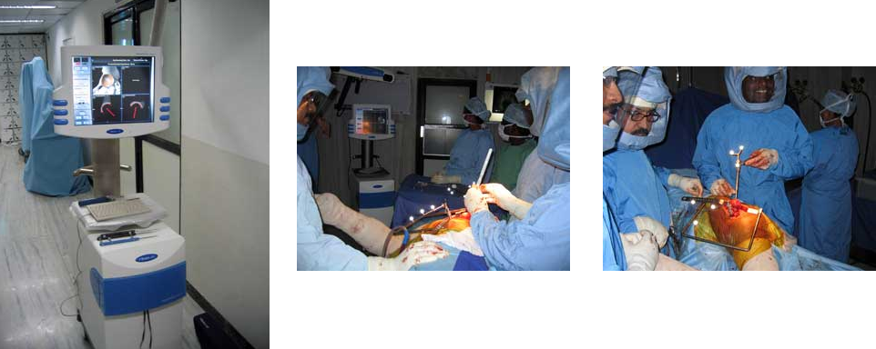

Computer aided navigation system Surgical hoods.

http://en.wikipedia.org/wiki/Asian_Regional_Center_for_Hip_Resurfacing

http://www.hipresurfacingindia.com/hip-resurfacing.php

Advantages of Hip Resurfacing at ARCH:
- Tired of waiting lists, Europeans and Americans looking for world class treatment at less cost are heading to India.
- State of the art hospitals, skilled doctors and advanced medical technology are luring patients to Indian hospitals.
- Hip resurfacing surgery is one such procedure for which more than 15 patients come to Apollo specialty hospital for treatment.
- The icing on the cake is a nice vacation in the sandy beaches of Chennai.
- Low cost and Best Hip Resurfacing in Asian Regional Center for Hip Resurfacing.
- Specialists in Hip Resurfacing Surgeries.
- Highest number of Hip Resurfacing surgeries 1000 done so far.
- Very Good Treatment after the surgery
- Platinum ward Facility – World class best treatment.
- Medical Tourism in India

Testimonies from some of the Patients
Cory Foulk started competing in iron man Triathlon 10 month following his Hip Resurfacing surgery with Dr. Bose. He has inspired many international athletes who were lost without a viable solution for Hip Pain to go down the resurfacing route.
Cory spoke to a gathering of the top 300 Hip Surgeons in the world regarding his Hip Resurfacing Surgery that he had at Apollo specialty Chennai and received a standing ovation..

A firefighter from Canada Rod Beiller flew to Chennai for Hip Resurfacing surgery then not available in Victoria. He escaped the wait-your- turn-healthcare-system in Canada to have his new hip sutured in the sunshine of Chennai. He went back to his job as a firefighter in three months.

http://www.youtube.com/watch?v=2_BnhZMeIw0
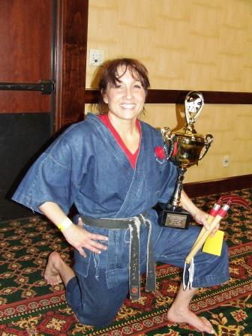
Linda Pugilese won the weapons division of Karate National Championship 2007 in U.S.A., One Year after both her hips were resurfaced by Dr. Vijay C Bose in Chennai.

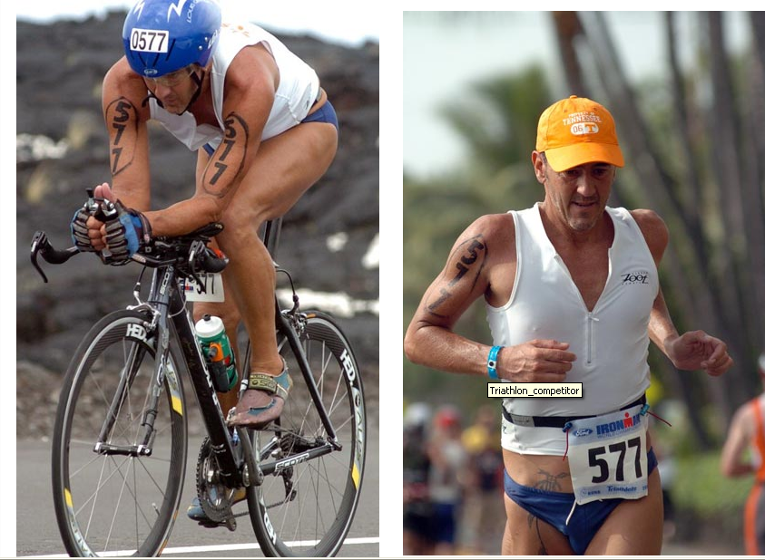

Dr. William Cory Foulk took part in the 2006 Ironman Triathlon world Championship ten months after having a Birmingham hip resurfacing procedure with Dr.Vijay C Bose

Birmingham Hip Resurfacing 1year follow up
Hip resurfacing With Dr Bose: Jeff Dolinsky "Golden Hippy"
"Hip Resurfacing with Dr Bose "Jeff's Walking Tour"
Live Surgery Videos by Dr Vijay C Bose:

Birmingham Hip Resurfacing Surgery- Vijay Bose Part 1
Hip Resurfacing (Birmingham ) Surgery- Vijay C Bose Part 2

Hip Resurfacing (Birmingham ) Surgery- Vijay C Bose Part 3

For More Details for Hip Resurfacing, Total Hip Problems
Dr. Vijay C. Bose – Specialist in Hip Resurfacing

Consultant Orthopedic Surgeon
Asian Regional Center for Hip Resurfacing
Apollo Specialty Hospital, 320, Mount Road, Chennai - 600035. INDIA.
E-Mail: bose5vijay@hotmail.com
Telephone: 0091-44-(0) 98400 - 32251
Visit Us: http://www.hipresurfacingindia.com

