# The Development of Humanistic Psychology



[Image Credits](https://unsplash.com/photos/bY5OUwKx3XU)

From a divergent psychological perspective, humanistic psychology rose to prominence in the mid-20th century. It openly challenged the limitations of [B. F. Skinner's Behaviorism](http://www.differencebetween.net/miscellaneous/difference-between-functionalism-and-behaviorism/) and Sigmund Freud's Psychoanalytical Theory.

Many have debated over the fact that it has deep roots originating from Socrates and a brainchild of the cognitive prowess erupting during the Renaissance period.

Regardless, one of the most prominent aspects of humanistic psychology is defining individuals' inherent drive to achieve self-actualization. This is the process of realizing one's own creativity and capabilities.

According to the [US Bureau of Labor Statistics](https://www.bls.gov/ooh/life-physical-and-social-science/psychologists.htm#:~:text=Employment%20of%20psychologists%20is%20projected,degree%20in%20an%20applied%20specialty.), psychologists' employment is projected to grow 3% from 2019 to 2029, with the best prospects for doctoral degrees in an applied specialty.

Furthermore, the median pay for 2019 was around $80,370 per year. Moreover, the number of jobs was estimated to be around 192,300 in 2019, with an expected change of 5,700 during 2019-2029. With that out of the way, let's take a quick look at how humanistic psychology has developed over the years.

## Introduction of Self-Actualization

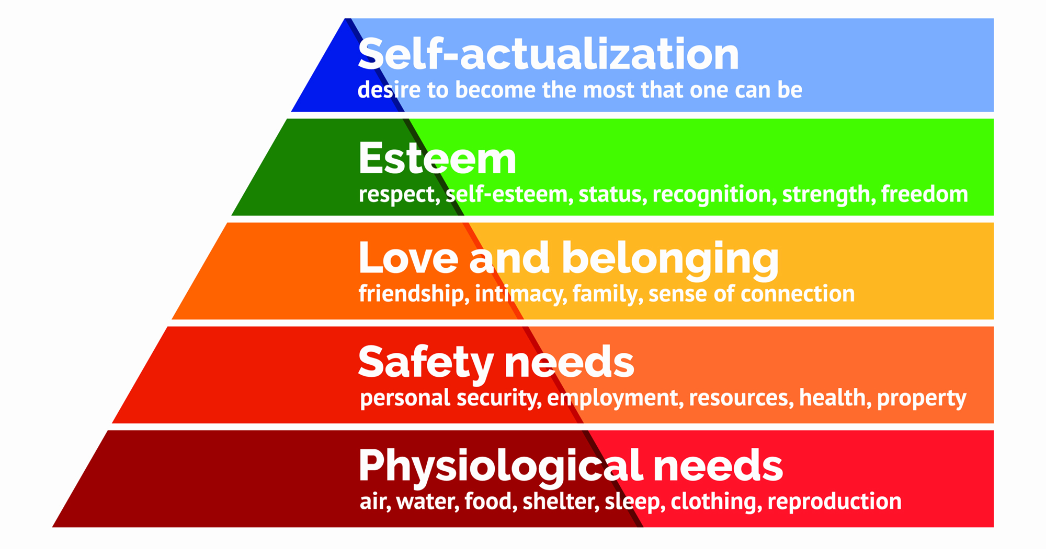

[Image Credits](https://www.simplypsychology.org/Maslows-Hierarchy-of-Needs.jpg)

If you have read Maslow's Hierarchy of Needs, you would know that self-actualization is the highest psychological development level.

This is where a person is able to accomplish their [personal potential](https://www.curezone.org/upload/PDF/WIEL/The_Nature_of_Personal_Reality.pdf) fully. This is considered part of Maslow's work and was primarily developed to combat the psychodynamic approach by Sigmund Freud that mainly focused on unhealthy individuals' disturbing behavior.

Most of the concept came during 1943, and study of the concept continued till 1954. The origin of the concept can also be found in Maslow's earliest discussions of self-actualization in a 1943 article called "The Theory of Human Motivation".

## Phenomenology & Existentialism

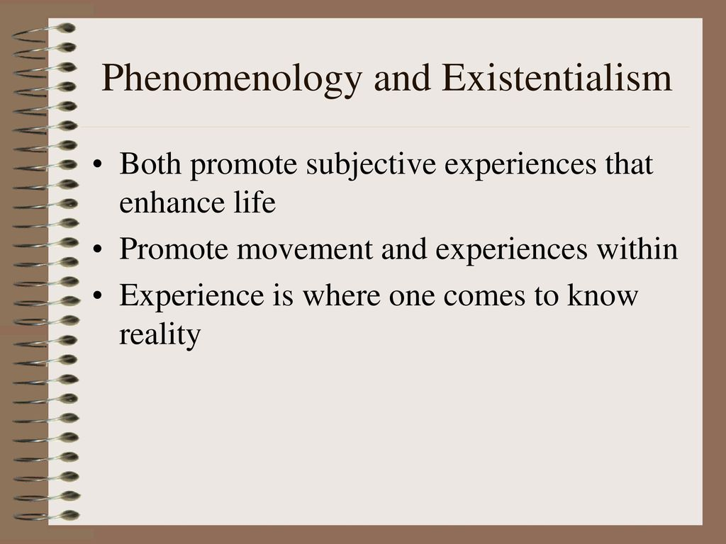

[Image Credits](https://slideplayer.com/slide/13084029/79/images/39/Phenomenology+and+Existentialism.jpg)

When talking about the early origins of humanistic psychology, one simply cannot deny that it took inspiration from existentialism and phenomenology. Phenomenology and its philosophical investigations regarding human consciousness were actively conducted in the early 20th century.

Many critiques regard Edmund Husserl's work on phenomenological philosophy as a major contribution as well as a strong influence from Heidegger during 1963.

As for existentialism, it is associated with several 19th and 20th-century European philosophers. They were the ones who emphasized the human subject, with Soren Kierkegaard being generally considered the first existentialist philosopher.

## Abraham Maslow, Carl Rogers, & Rollo May

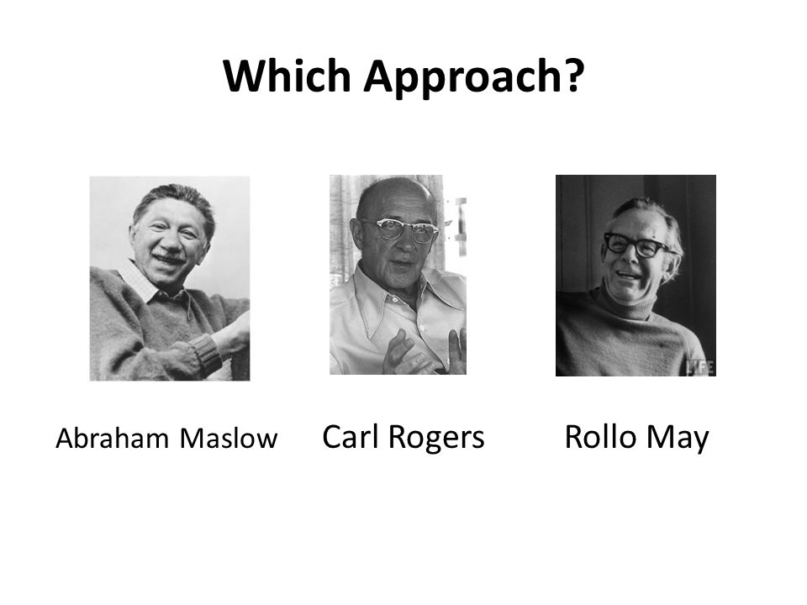

[Image Credits](https://slideplayer.com/slide/10822087/38/images/35/Which+Approach+Abraham+Maslow+Carl+Rogers+Rollo+May.jpg)

The major theorist behind humanistic psychology and its development, as well as laying the foundations and to the point they were revered as a force to be reckoned with, including the likes of:

* Abraham Maslow – ranked as the 10th most cited psychologist of the 20th century. He stressed the importance of focusing on positive qualities in people as opposed to treating them as a "bag of symptoms".
* Carl Rogers – an American psychologist and amongst the founders of the humanistic approach to psychology. For his professional work, he was presented with the Award for Distinguished Professional Contributions to Psychology by the APA in 1972.
* Rollo May – an existential psychologist who was a major proponent of existential psychotherapy. He is famous for his work on "The Meaning of Anxiety" in 1950 and revised in 1977.

Some may argue that each of them presented their own unique views, and pupils who seek [dissertation writing services](https://firstclassdissertation.co.uk/dissertation-services) may read further about them to have friendly discussions with their peers.

## Five Core Principles

James Bungental was one of the predominant theorists as well as an enthusiastic advocate of the [Existential-Humanistic Therapy movement](https://www.ccpeweb.ca/en/services/psychotherapy/humanistic-existential-approach/#:~:text=The%20humanistic%20approach%20was%20introduced%20in%20the%201940's%20in%20the%20United%20States.&text=Whereas%20the%20key%20words%20for,the%20client's%20responsibility%20and%20freedom.).

By 1965, in his work called "Search for Authenticity," he recommended five core principles or postulates as they are commonly known that governed humanistic psychology. These are:

1. Human beings cannot be reduced to components as they supersede the sum of their parts.
2. Human beings have a uniquely human context that is part of their existence as well as in cosmic ecology.
3. Human beings are conscious beings as they are aware as well as aware of being aware, including awareness of oneself in the context of other people.
4. Human beings have choices and responsibility as well as the ability to make choices, therefore having responsibility.
5. Human beings seek meaning, value, and creativity. They aim at goals and are intentional with an awareness of their actions, causing future events.

Students looking for a [research proposal writing service](https://dissertationassistance.co.uk/research-proposal-service) may consider reading more about these postulates during their leisure time.

## Scientific Research & Later Developments



[Image Credits](https://upload.wikimedia.org/wikipedia/en/thumb/2/22/American_Psychological_Association_logo.svg/1200px-American_Psychological_Association_logo.svg.png)

Research has always been a main part of the agenda when it comes to humanistic psychology. In 1980 APA (American Psychological Association) published an article titled "[What Makes Research Humanistic](http://methods.sagepub.com/reference/the-sage-encyclopedia-of-social-science-research-methods/n403.xml#:~:text=Humanistic%20research%20is%20research%20that,humankind%20in%20a%20global%20context.)".

While ever since its inception, humanistic psychology has involved scientific research on human behavior. Today you can find Division 32 of APA publishing its own academic journal called The Humanistic Psychologist.

## Conclusion

When it comes to humanistic psychology, its principal professional organizations in the US are none other than AHP (Association of Humanistic Psychology) and SHP (Society for Humanistic Psychology).

In Britain, you also have the UK Association for Humanistic Psychology Practitioners. Today it exists as a much distinct from that implies more humanistic approaches as compared to behaviorism and psychoanalysis.

As a result, it is now being deployed in various organizations around the world to study creativity and new approaches towards human capital at workplaces. Hence you can find several individually licensed counselors and therapists who practice humanistic psychology as a profession.

## Author Bio

Stella Lincoln currently works as an Assistant Editor at [Assignment Assistance](https://assignmentassistance.co.uk/do-my-essay). She is quite fond of surfing the internet to find life hacks she could try at home. During her free time, she practices mindful yoga and takes meditation classes by renowned instructors online.