Building A Post-Chaos Community
Wednesday, 14 January 2009 06:56
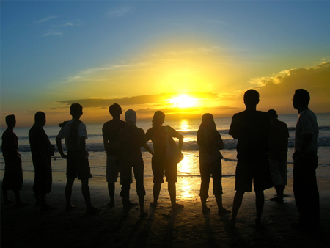
When building a survival community it is necessary to not only think of how to survive the chaos of the next few years but how to build in order to be prepared to survive the long term future.
Surviving the five to ten years of war, famine, disease, geologic change and general population destruction and upheaval has its obvious requirements, Location, Shelter, Food, Medicine.
All of these are equally important for the long term survival of the community, but the most important ingredient of all is the People who join in any community. While it is true that the purchase of property with good water available and supplies is an expensive undertaking, no amount of money can make up for having inappropriate members living in the community. There is one key word which is a litmus test for future residents and it is "usefulness". Unfortunately in this day and age , with some exceptions, the money is in the hands of people with few skills in terms of survival so what is it we need to look for when talking with prospective fellow residents in a community? Here are a few guidelines for long term success;

1.LOCATIONS;
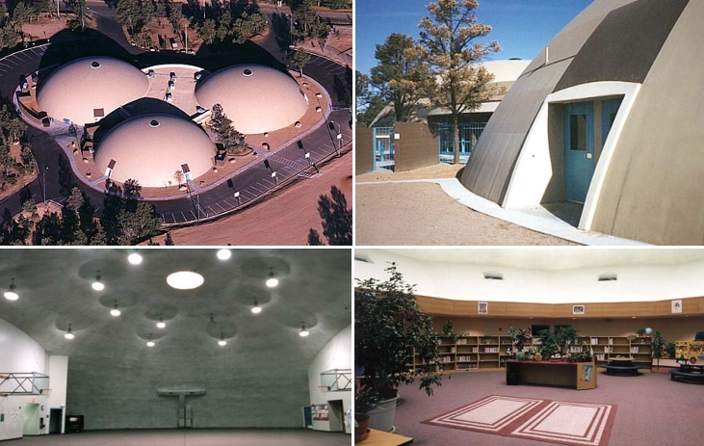
Choose locations with plenty of water. Remember that wells, springs and even small rivers and lakes can be easily destroyed by earthquake activity. A copious supply and suitable storage are necessary. Storage of water should take into account the need to protect against ALL FORMS of contamination in order to ensure good drinking water. It is worthwhile remembering that water stored in underground cisterns by the Romans 2000 years ago was still fresh when discovered in recent times.
Having found suitable locations communities should be sited approximately 50 miles apart (in all directions). The reasoning for this spacing is twofold;
Firstly, it is not an unreasonable walking distance and will therefore ensure that, once established, these future villages will remain in contact even if no general transport (cars, etc.) is available and will thereby continue the exchange of knowledge and hopefully prevent these small societies from degenerating intellectually.
Secondly, an area with a 25 mile radius will provide an adequate hunting/ farming area around each village.
2. SHELTER;
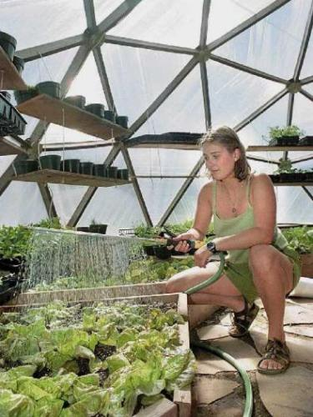
Whilst it is recognized that some immediate emergencies may require underground protection for a short period it is not a desirable thing for people to live below the earth for extended periods. Villages will best be served of one large central community building with underground capability is constructed and surrounded by individual homes of the concrete dome type (as Monolithic). These structures are suitable for ALL climates as they stay relatively warm in winter and cool in summer, they are vermin proof and, if ever necessary, could be covered with earth either permanently or temporarily. (As an aside it may be considered that many areas of the planet may well see a mini ice age before we need to worry about too much warming)
3. FOOD;

As mentioned, a 25 mile radius around every village will provide adequate land for food, provided of course the area is well chosen. As there will most certainly be a depletion in game and no supermarkets handy it will be as well to have a minimum of 3 years food basics in storage to provide a healthy diet for the entire community. Storage should contain mainly dry goods like rice, grain, pasta, assorted beans etc. but a good supply of canned goods which could be eaten as is will be very useful, especially until water for cooking and kitchens are available. Food production should be the number one priority during the first year and should have three aspects 1. Hunting/Growing. Red meat and fish are not essential to the diet and it will be as well to let nature replenish itself without interruption for as long as possible, taking game food only when really necessary. 2. It will be best to focus on growing food using non-hybridized seeds to ensure future crops, This will require clearing and planting land, being first sure it is not contaminated. And 3. at the same time building large dome shaped green houses both for regular and hydroponic gardening. Be sure there is plenty of instructional literature available.
4. MEDICINE;
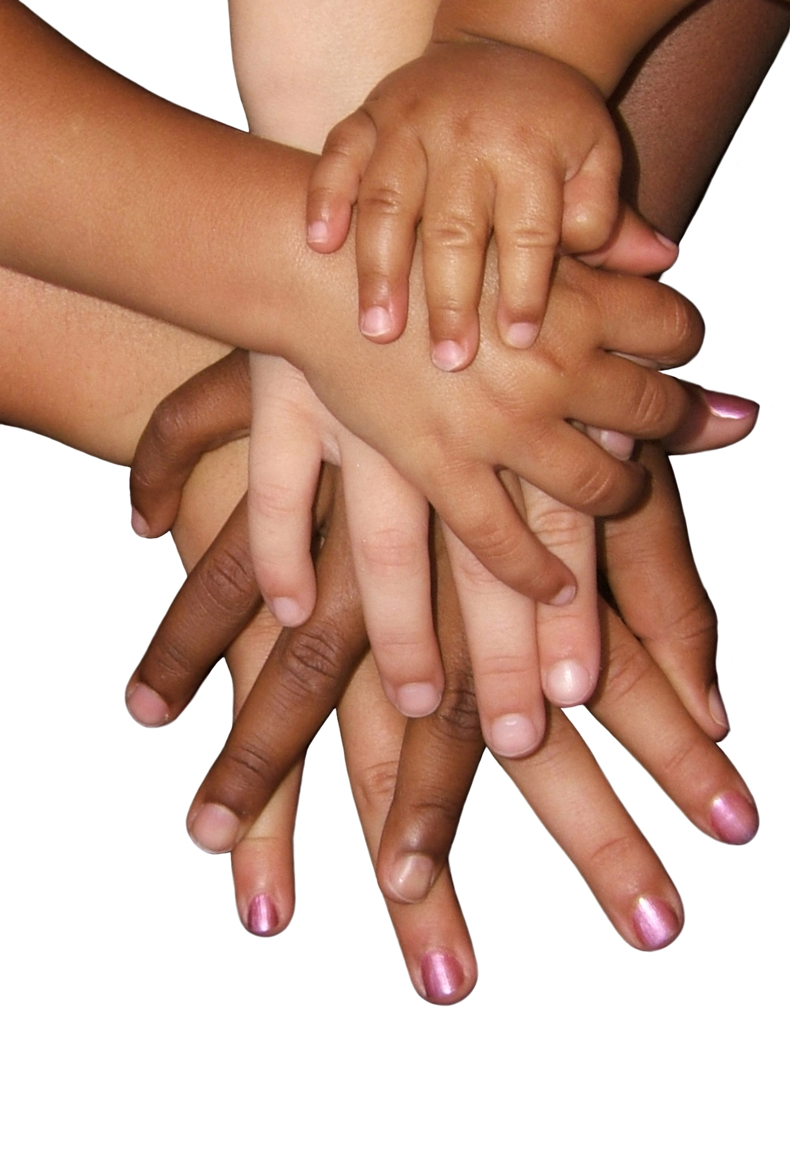

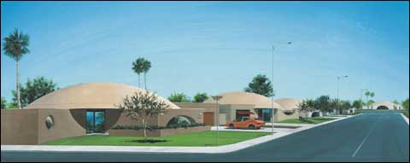
The production of pharmaceutical companies will not be continuing. Therefore, to carry the needs of the village for the first year or two, while real survival ability is being developed, it will be wise to carry a good stock of medical basics such as antibiotics, disinfectants, analgesics as well as surgical fundamentals. There should be sufficient equipment for surgical and dental procedures to serve the community and a substantial library of written and pictorial medical literature.
A separate building just outside the village area should be kept for medical use. This building will also serve as a guest residence for visitors from the outside who can be quarantined there until it is certain they are carrying no diseases into the village community. This will be especially important for the first few years and must be rigidly held to if the villages are to survive. This building will therefore have its own water and waste disposal system. Septic tanks will be more than adequate if properly built.
MEMBERS OF THE COMMUNITY
Now to the most critical part, the formation of the community; The People, design and ordering of the village as a whole unit.
When establishing the villages there needs to be a minimum of 400 persons, with, perhaps,only a very few more. The reason for this choice of numbers is because it requires not less than FIVE hundred to maintain a healthy gene pool. By establishing each village with 400 souls it will encourage the meetings and exchanges between communities to find some partners outside the village and aid in maintaining exchange of information and ideas.
The following questions should be considered when choosing who will share the community.
AGE. The first communities need a high proportion of young healthy adults, with or without small children. 80% between the ages of eighteen and thirty-five would not be unreasonable.
USEFULNESS. What can each person actually do? For a mixed community of 400 persons a good guide would be say, 4 teachers, 3 doctors, 1 chiropractor, 1 herbalist, 1 horticulturist, 2 agriculturists, 2 nurses, 1 writer, 1 musician, 1 artist, 4 cooks, 2 hunters, 1 engineer, together with carpenters, builders, mechanics, farmers and persons knowledgeable in such things as needlework, fabric making, paper and candle making--in other words, people who can actually do something which may be useful to the company.
It should be made clear from the start that ALL those with professional qualifications will be required to teach those skills to others and that NO qualification will exempt anyone from their share of the communities chores.
Once the village has been assembled let it choose a leader to coordinate all their efforts. This should be some one of science not a religious leader. All matters of religion should be entirely personal for the sake of the whole.
ORDERING THE COMMUNITY
First let the village leader ask for a few volunteers to form the first council, about five persons .
Next let these five determine which are the villages most urgent needs and allocate the work. This is only to get things up and running and everyone should be willing to participate to the best of their ability.
Now establish a LIST OF COMMUNITY CHORES. This may include such things as water hauling, garbage sorting and disposal, maintaining community buildings, digging ditches for drainage, clearing land building shelters etc, Everyone, without exception will need to take a turn with the village chores on a rotating basis. The village council will establish both the list of chores (which will be adjusted from time to time) as well as the rota. Once the village has its basics in place,( estimate 3 months time with all working on the project to the exclusion of all else), then an estimated 2 hours a day, five days a week, for all persons over the age of twelve should be adequate to maintain and continue development of the village. At this point some degree of specialization comes in. Farmers farm, teachers begin to establish school, doctors take care of the sick and begin to train replacements and so on. However, each person will now begin to develop patterns for the future of the village by volunteering some of their spare time to teaching others whatever skills they individually have---to sew, paint, play etc. With this in mind, every adult will give some time (maybe one day a year?) to teaching school--- everyone has some story to tell, how to build a hen house, when I was young, how to swim--- whatever anyone knows will be passed down to the young.
Once in the community no one will be considered old and useless. The great contribution of those who grow too old to work will be to keep records, watch children, tell stories, write books, paint pictures--dozens of useful things to make life better.
As it is intended that only ten hours a week will be needed after a short while to maintain the necessities of village life, after that each person is free to follow their own calling and use all spare time as they see fit. The only thing which it is recommended not to be sanctioned is the "paying" of someone else to do an individuals work. If anyone needs to be excused from participation in the community chores let the village council decide---obviously, if there is an accident the doctor is needed more at the hospital than on the ditch digging, but these excuses should be as few as possible.
To make all this work and create a happy life for everyone in the best possible way it is advisable to change the council members every three months and to put the continuation of the leader to the vote once a year, assuming the leader is willing to continue. The council should be selected from volunteers but it should be understood that all adults will have to take a turn at being of the council. This will work well once the pattern of the village is established as it is on the principle of "you cut the sandwich, I choose which half". Fairness is a main priority in all these suggestions for establishing village communities which can and will successfully continue and expand the human experience on planet earth.
HOUSING
The Monolithic type of dome construction was mentioned earlier, and these are ideal for their earthquake resistance and ability to withstand high wind, which wind may reach hundreds of miles an hour during the times ahead. But there are other types of construction which may also serve well, for example the earth ships made with old tires and compacted dirt or sand and the adobe style homes. Be sure to have instructions for these wind resistant homes in the library along with as many "how to" books, like the Fox Fire series, as you can find. It would also be useful to make a collection of sensible small tools and appliances which may be copied and reproduced at a later date as need and energy become available, as well as a selection of non-energy using equipment, for example, hand grain grinders.
Although the above suggestions will work for any planned community they are designed with the "worst case scenario" in mind. Let us hope it never comes to that, but if it should, then we would be well prepared if we had taken these steps. It is envisaged that a core group of people, possibly with outside help, will begin preparing these village areas and an important part of that preparation would be the collection of the biggest library possible with every kind of book from medicine to poetry. An old hand set printing press would also be a great addition to the library, which would be housed in the central dome.
These basic guidelines for village life in the aftermath of disaster are designed to give the opportunity for man to recover and grow in an environment which is fair and just. One where each person takes loving care of himself, his family and his neighbor and where everyone has a chance to share in the whole and at the same time develop his own talents and individuality to the best possible degree.
Prepared by Gillian Green 2008

