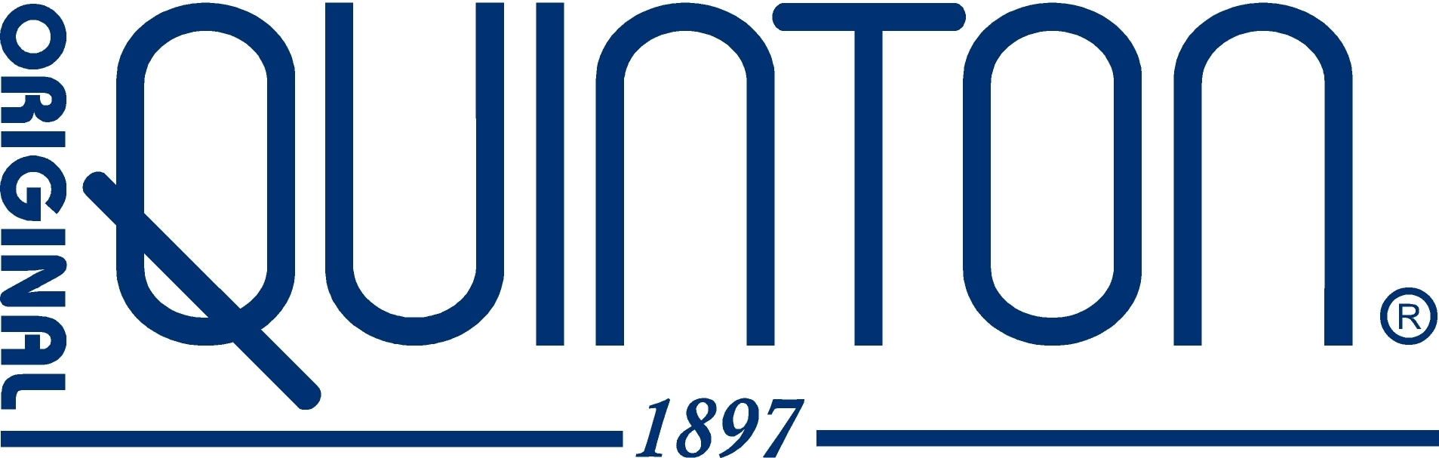

What is Quinton Marine Plasma?

Quinton Marine Plasma is a natural marine solution that has 100 years of clinical evidence supporting its therapeutic and health regenerating properties. Since 1897 Quinton Marine Plasma has been harvested from a unique vortex plankton bloom in the Atlantic Ocean. Here, biological activity known as Biocenosis - a complex interaction among the all minerals and trace elements, organic matter, microbes, RNA, DNA, phytoplankton and zooplankton – is at its peak. Raw seawater from this location exhibits special biochemical and energetic properties that are distinct from the surrounding ocean.
After extraction from a depth of 30 meters, the solution is transported at 4ºC in sterile containers to Laboratoires Quinton, a certified pharmaceutical facility in Spain. Minimal processing, cold-sterilization and packaging in double-tip glass ampoules are the hallmark of this unique product. Heat sterilization and radiation are never used so that its “living” quality and efficacy are preserved 100%.

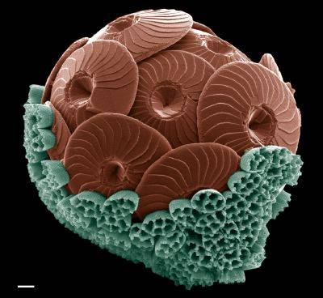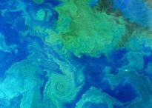

What was Rene’ Quinton’s amazing discovery?

Rene’ Quinton discovered that our animal “milieu interieur” (biological terrain, extracellular matrix, ground substance, etc.) was literally inherited from the primordial isotonic ocean in which the first unicellular life began and developed. This “original” biological terrain was maintained throughout the zoological chain for nearly 2.5 billion years and is our single most enduring physiological trait.
Rene’ Quinton described it so eloquently:

“We are truly a living marine aquarium.”
What is the significance of the “milieu interieur” in modern medicine?

The “milieu interieur” or biological terrain was defined by the father of physiology, Claude Bernard, in the mid-1800’s. The terrain comprises the complex network of all of our body fluids and accounts for nearly 70% of our body weight. Modern physiologists acknowledge the terrain as the very foundation of physiology because all physiological processes take place within it.
Recent developments in science, medicine and genetics attribute an even greater role of the biological terrain to immune response, cell replication and homeostasis. It appears that Claude Bernard was correct when he proposed:
“The terrain is everything”.
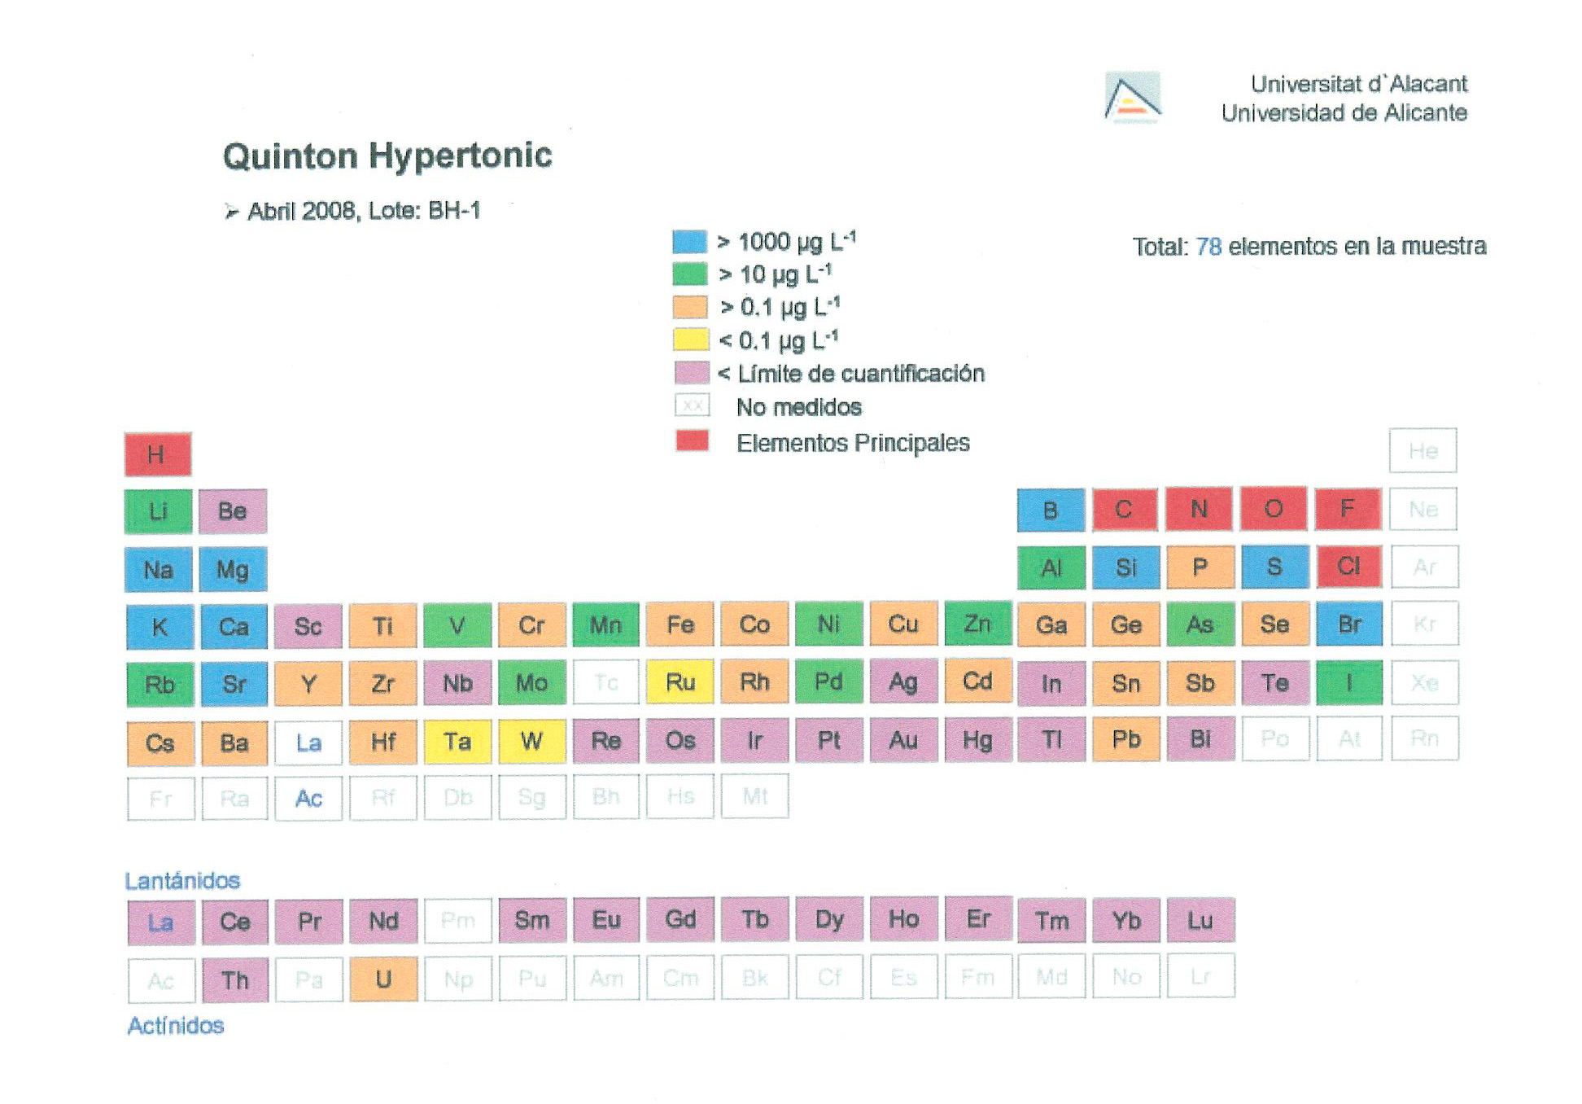

What did Rene Quinton prove about his discovery?

Rene’ Quinton was able to duplicate the composition of the primordial sea by diluting his unique ocean extract. Time and time again, he then proved the physiological compatibility of his Plasma de Quinton by replacing both 100% of the blood plasma and 100% of the whole blood of small animals with no adverse effects (You read it correctly!). These experiments were documented in minute-by-minute detail in his scientific treatise of 1904, L’eau de Mer, Milieu Organique. As further proof, the Marine Plasma was subsequently used in both World Wars as a blood plasma replacement and it is still used today in clinics around the world.
In the years following, Rene’ Quinton demonstrated something even more incredible to the medical community: He proved that his Plasma de Quinton, when properly introduced into the body, is able to biochemically replenish the human biological terrain and impart a “blueprint” which reestablishes global balance within the extracellular liquid matrix. The effect of this is a shift toward homeostasis so significant that even the most serious illnesses were controlled and overcome.

How extensively was Quinton Marine Plasma used after its value in medical treatment was first demonstrated?

By 1908 Europe was facing some of the greatest epidemics of disease in its history. In the absence of antibiotics, which had not yet been discovered, cholera, typhoid, tuberculosis, syphilis and a myriad of gastrointestinal and skin diseases were causing millions of deaths and suffering. Antibiotics were thirty years away. Based on Rene Quinton’s success in treating scores of otherwise doomed French patients, the Paris Academy of Medicine elected his Marine Method as the best hope for the worsening epidemics.

Six European countries as well as Egypt and Algeria established 69 free clinics to administer Quinton Marine Plasma to their diseased populations. These Marine Dispensaries, as they were called, were such a legendary success in saving more than a half-million lives that Rene’ Quinton was hailed as one of France’s most distinguished heroes. Today we are left with an amazing legacy of this accomplishment, Le Dispensaire Marine, which is a six-hundred page clinical summary, of the work of Rene Quinton and his chief physician, Dr. Jean Jarricot. This masterpiece is considered to be one of the most detailed and extensive clinical studies in medical history.
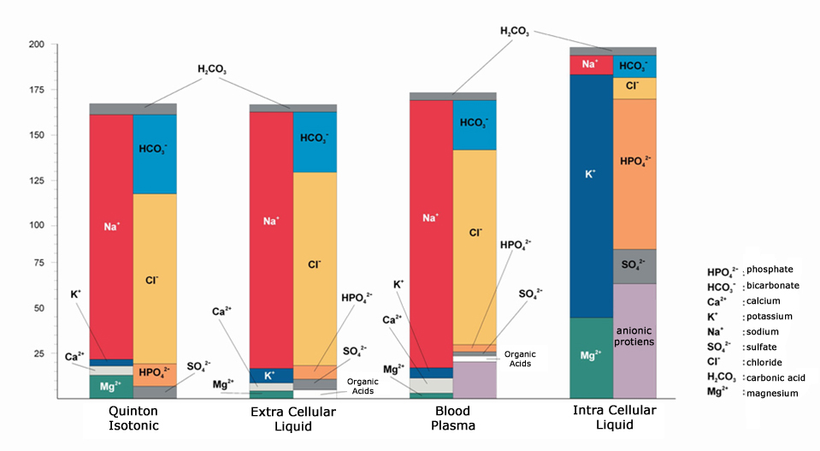
Is it true that Rene Quinton and Dr. Jean Jarricot may have performed the first clinical demonstration of epigenetics more than a century ago?

The science of epigenetics was officially born when Randy Jirtle (Duke University) demonstrated that certain genes of laboratory mice could be “turned off” by the addition of extra nutrients in the diet (folate in this case). Sadly, the scientific world had forgotten (or suppressed?) that Quinton and Jarricot, more than a century before, demonstrated a far more dramatic epigenetic transformation - not on mice but on the fetuses of 2000 pregnant women! Mothers who had a long history of bearing children with congenital disease and serious birth defects were administered Quinton Marine Plasma during pregnancy and their subsequent offspring were nearly 100% free of any physiological or mental adversity. These “Quinton Babies”, as they were called, were tracked for as long as 15 years to prove the long-term efficacy of the Marine Therapeutic Method (Le Dispensaire Marin, 1925)

How does Quinton Marine Plasma serve practitioners and their patients?

One reason why the practice of modern medicine tends to steer clear of addressing health conditions from the perspective of the master regulator of all physiological processes, the biological terrain, is that the subject matter is so complex and involved. For those practitioners who are willing to develop a basic therapeutic skill set anchored in the use of Quinton Marine Plasma, a window of access and influence over this physio-regulatory matrix will open and reveal an important key to achieving homeostasis for their patients – without any known primary contra-indications.
Quinton Marine Plasma offers a wealth of modalities that yield numerous comprehensive benefits to both practitioners and patients alike. It is, in effect, a holistic influence using just one or two concentrations, Isotonic and Hypertonic, for both internal and external use. The oral, nasal, dermal, ocular, dental, respiratory and colonic application of Rene’ Quinton’s gift have ability to become cornerstones of your successful medical practice.

Contact: Original Quinton North America
6900 Aragon Circle, Buena Park, CA 90620
Tel: 888-278-4686 Fax: 714-522-7195
www.originalquinton.com

