Exfoliative Cheilitis
Abstract
Exfoliative Cheilitis (EC) is defined as “a chronic inflammatory disorder of the vermillion border of the lips, which is characterized by the persistent formation of scales and crusts.”¹ A rare disease with no known cause or cure, EC is commonly seen in the young more than the old and in women more than men.² Unfortunately, the reasons behind this age and sex discrepancy are unknown. In fact, little about EC is known at all. This paper will summarize the research done on EC, and hypotheses as to the cause and the cure of EC will then be posited.
The Symptoms of Exfoliative Cheilitis
A recent paper on EC, which reviewed the literature, listed the symptoms that patients tend to have in common.⁶ Patients often report a 3-5 day cycle beginning with seemingly normal skin on the lips for the first day or so.¹ Around day two or three, the skin begins to harden in a consistent way and on the same areas of the lips. By the third or fourth day, the skin is unbearably hard, and the sufferers often peel away the tough skin. The skin will also occasionally fall off naturally when the mouth is opened too wide for the dead skin to remain intact. As an example, the eating of an apple around the third day will often remove the dry skin. After the dead skin is removed, the cycle begins again. Some patients report that they have gone through this cycle for more than a decade.⁶
Patients invariably confess to biting, licking and peeling the lips.⁶ Many patients also report being on Isotretinoin, a medication that causes abnormally dry lips.³ When the patients were taken off of this drug, the dryness of the lips remained while all other reactions to the medication ended. The cessation of lip biting, licking and peeling did not seem to help cure the condition.
Treatments for EC
Doctors and patients have tried almost every type of treatment for this condition without success. Nearly every sort of steroid cream or medication has been prescribed with no visible improvement. Patients have gone to such extreme as surgeries, cauterizations, liquid nitrogen, and any number of natural remedies to cure the disease, but nothing has been effective.⁷
In all of the literature regarding EC, only one paper has reported a cure. Through the use of topical Tacrolimus, a patient’s EC completely healed.⁴ However, many of the sufferers of EC state that they have used Tacrolimus with no success. With no other literature reporting a similar cure to the disease, it must be assumed that the patient successfully treated with Tacrolimus was falsely diagnosed with EC.
Biopsies of the lips have been reported on several patients. In the research papers, hyperkeratosis, an overgrowth or thickening of the outer layer of skin, is the only abnormality that is ever found.⁷ A yeast infection is occasionally reported, but the disease remains even after this has been cured. Patients are often given allergy tests, but the condition persists even with negative results.
A Deeper Look at EC
All sufferers of EC report that they have a tendency to bite, pick, and lick their lips. However, the literature on the subject fails to notice the impact that these habits have had on the skin (Figure 1).
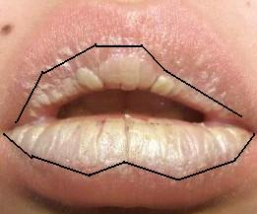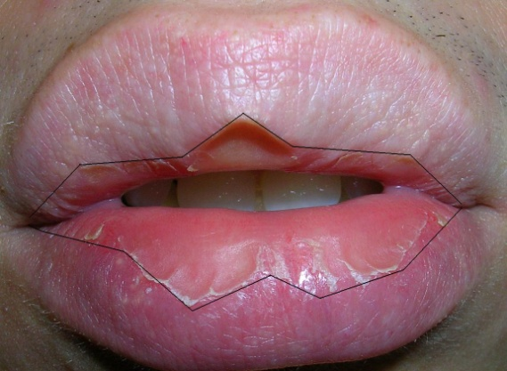
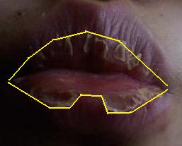
Figure 1: The above pictures all show the characteristic pattern of the affected area. The region of the lips that has abnormal skin is the only area in reach of the tongue.

It appears that EC only affects the skin that can be touched by the patient’s tongue. This fact is significant in that the patients all report biting, licking and peeling their lips. The only skin that shows symptoms is where this can occur. It is also important to note how the lips appear when the hardened skin is removed (Figure 2). The affected area remains in the proximity of the tongue, but the skin is red. This color is a result of the top layer of skin being removed revealing the layer below.
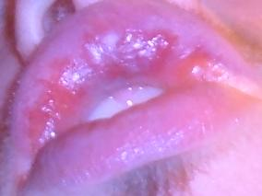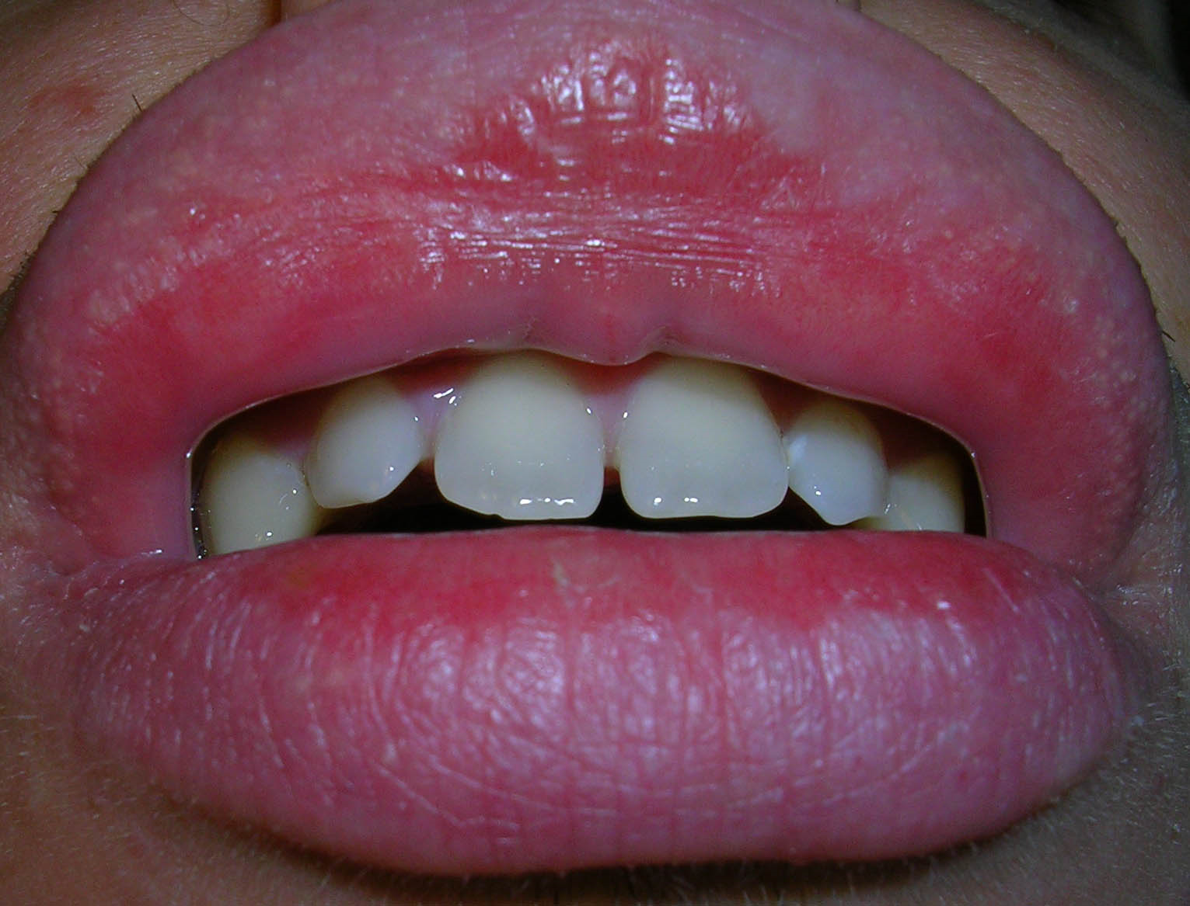
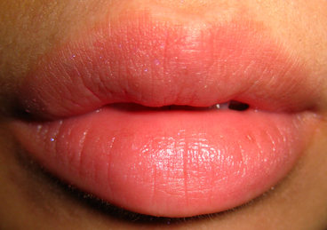
Figure 2: The skin is red and raw where the hardened, dead skin has been removed. Also, notice how the affected skin is still in the shape of the tongue. Healthy lips are shown in the bottom picture to serve as a comparison.

A Hypothesis Regarding the Cause of EC
A review of both the literature and the patient histories leads to the following observations regarding EC:
- All patients report licking, biting and peeling their lips
- The only skin affected is in the shape of the tongue. The skin out of reach of the tongue is normal

- Patients typically test negative for allergies
- The only abnormality found in biopsies is hyperkeratosis
- All patients suffer from the same 3-5 day cycle of hardening and peeling of the skin
- Common sufferers of EC include patients who were once on Isotretinoin
With all of these facts in mind, a simple, novel hypothesis can be reached which accounts for the above observations. Exfoliative Cheilitis is a callus of the lips. A callus is defined as “a thickening of the stratum corneum of the epidermis due to chronic rubbing or irritation.”⁸ To be more specific, EC seems to be a severe type of callus called a clavus or corn. A corn is a “specially-shaped callus of dead skin that usually occurs on thin or glabrous (hairless and smooth) skin surfaces, especially on the dorsal surface of toes or fingers.”⁸ The similarity between a corn on the toes and on the lips is striking (Figure 3).
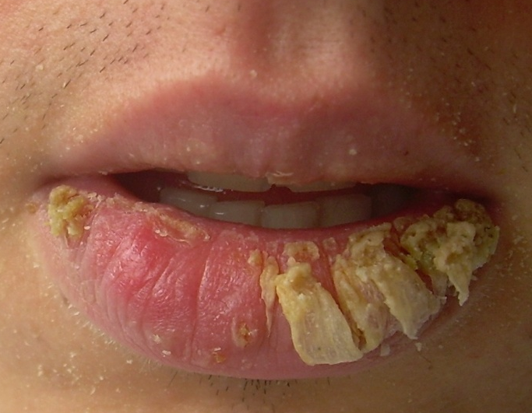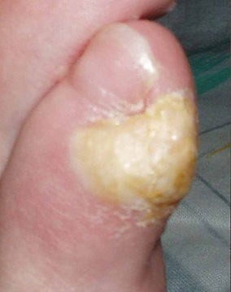
Figure 3: The skin formed by a corn on the toe looks similar to the skin on the lips of this EC sufferer.

As the tests confirm, the irritation is not brought about through allergies, and biopsies reveal hyperkeratosis as the only symptom. Thus, the disease is self-inflicted. Observation one, persistent biting and licking, accounts for the chronic irritation, and observation two, the affected skin is in the shape of the tongue, is a result of the biting and licking.
Many people on Isotretinoin suffer from EC because Isotretinoin causes severe chapping of the lips. Those who are on Isotretinoin often lick, bite and peel the skin of their lips due to the dryness caused by the medication. As a result, layers of skin are often removed repeatedly causing the callusing of skin. The skin remains callused long after the drug leaves the system, and the continuous removal of the skin never allows the callus to heal.
The three to five day cycle that is common for all sufferers of EC is consistent with the way skin heals. After the callus is removed, the skin is smooth and raw underneath (Figure 2). Two or three days after the removal of the stratum corneum, the proliferative phase of wound healing begins.¹ This point marks the beginning of the formation of the stratum corneum. However, the skin has been removed repeatedly, and hyperkeratosis results.
Why do some people develop EC and others do not, and why is it that not everyone on Isotretinoin develops EC? The answers to these questions are not known, but a critical point likely exists where the skin is harmed too much to heal without callusing. It is also possible that some people have stronger enzymes in their saliva, which causes the condition to be developed more easily. However, both of these hypotheses are unsubstantiated.
A Cure for EC
Unfortunately, the only known cure for corns and calluses involves leaving the skin alone for an extended period of time. A few sufferers of EC have reported success with this method, but they most likely had a mild form of EC. It can take months for corns to heal, and the skin is unsightly for much of this time. With the corns being on the face in the case of EC, most people simply choose to remove the skin every few days to reveal ostensibly healed skin rather than spending months with unpleasant looking lips.
Even if individuals do choose to let the skin heal, it remains difficult to do so. The lips are naturally elastic, while calluses are inelastic. Biting, chewing, smiling, and talking all cause the lips to stretch. When this occurs, the rough skin tends to separate from the smooth skin, and raw, wounded skin is exposed. Although a patient may be willing to brave the aesthetic problems with letting the callus heal, it may be impossible to do so for several months due to the inelasticity of calluses.
Summary
Exfoliative Cheilitis is caused by a callusing of the skin. The only cure for this condition involves leaving the callus alone for months, but the resulting corns are unsightly. A practical problem also exists in that calluses are naturally inelastic in an area that requires elasticity of the skin to function properly. Even if a patient is willing to leave the callus alone, it may be nearly impossible to do so successfully. If the hypothesis that EC is a callus proves to be correct, perhaps a cure will not be far off with the underlying problem accurately identified.

Sources

¹ Laskaris, George. Color Atlas of Oral Diseases. 2003. New York. Georg Thieme Verlag.

² Laskaris, George. Treatment of Oral Diseases: A Concise Textbook. 2003. New York. Georg Thieme Verlag.

³ Scully, Crispian. Handbook of Oral Disease: Diagnosis and Management. 2001. London. Martin Dunitz Ltd.

⁴ Connoly and Kennedy. Exfoliative Cheilitis Successfully Treated with Topical Tacrolimus. British Journal of Dermatology. July 2004, Vol 151, Issue 1. Pg 241-242.

⁵ Mani, Shani Ann and Ban Taweek Shareef. Exfoliative Cheilitis: Report of a Case. Journal of the Canadian Dental Association. Sept 2007. Vol 73, Issue 7. Pg 629-632.

⁶ Taniguchi and Kono. Exfoliative Cheilitis: A Case Report and Review of the Literature. Dermatology. 1998. Pg. 253-255.

⁷ Daley TD and Gupta. Exfoliative Cheilitis. Journal of Oral Pathology and Medicine. Apr 1995. Vol 24, Issue 4. Pg. 177-179.

⁸ www.thefreedictionary.com

